Laboratory 21: Amplifiers and Transformers
(Edit this document as needed)

Partner 1: _________Saaif Ahmed_______________

Partner 2: __________John Gonzalez_____________

Partner 3: _______________________________ (if needed)

Part A
Brief description of the Transformer simulation experiment:
Create a transformer simulation circuit using LTspice, analyze the output voltage and compare it with the input. Determine the operational requirements for transformers and how they function and what they do.

Plot of the input voltage and output voltage as a function of time, with annotations. (LTspice)

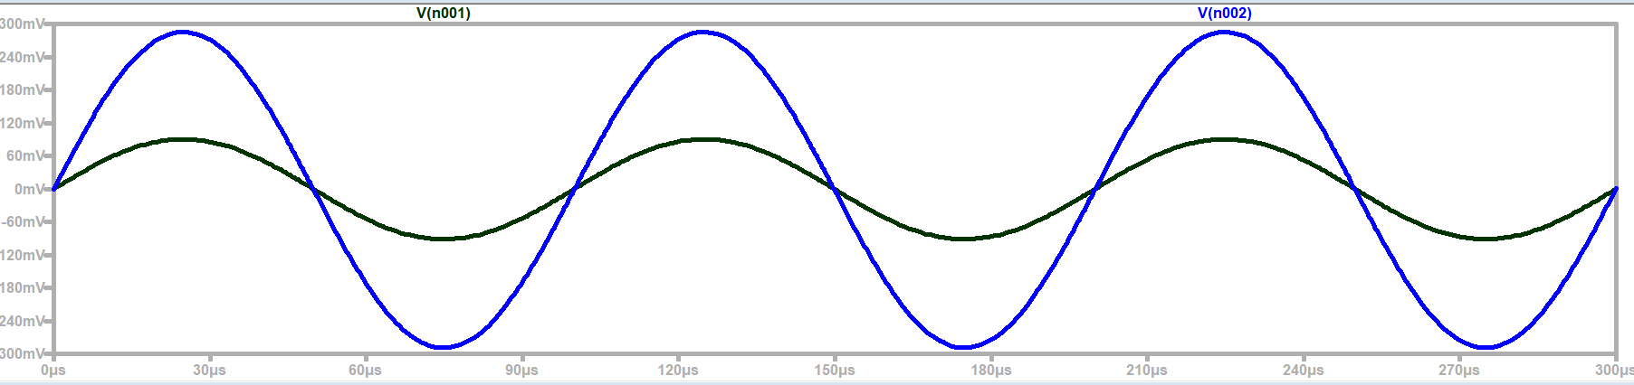
Output Max
Input Max
Output max: 290mV
Input max: 90mV

Estimate of the turns ratio, a, using the relationship between input voltage and output voltage.

a | 0.31

Plot of the primary and secondary currents as a function of time, with annotations. (LTspice)

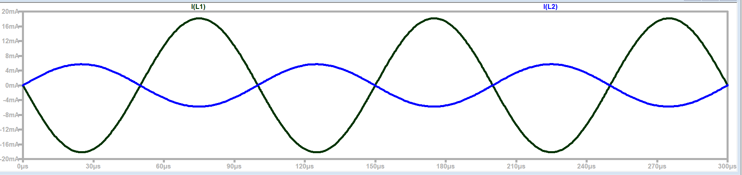
Input Max: 18mA
Output Max: 5.7mA

Estimate of the turns ratio, a, using the relationship between primary current and secondary current.

a | 0.31

Plot of transformer input impedance, Rin = V_{primary}/I_{primary}. (LTspice)

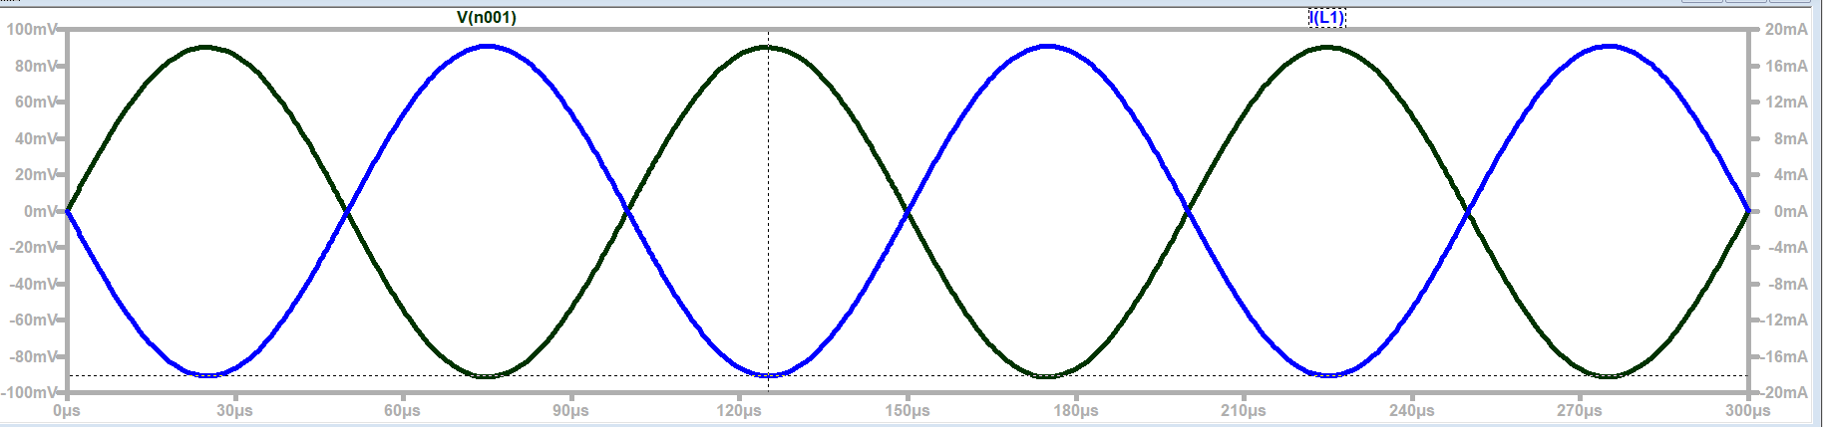

Estimate of the input impedance using the ‘flat’ region of the above plot.

Rin | 4.95[Ω]

Estimate of the turns ratio, a, using the relationship between input impedance and load impedance.
Z(in) =4.96
Z(output)=(50)

a | 0.31

Are all three estimates of the turns ratio consistent?
The estimates of the turn ratios are consistent.

AC sweep plot of the primary voltage, Vp, and turns ratio times the secondary voltage, aVs. (LTspice)

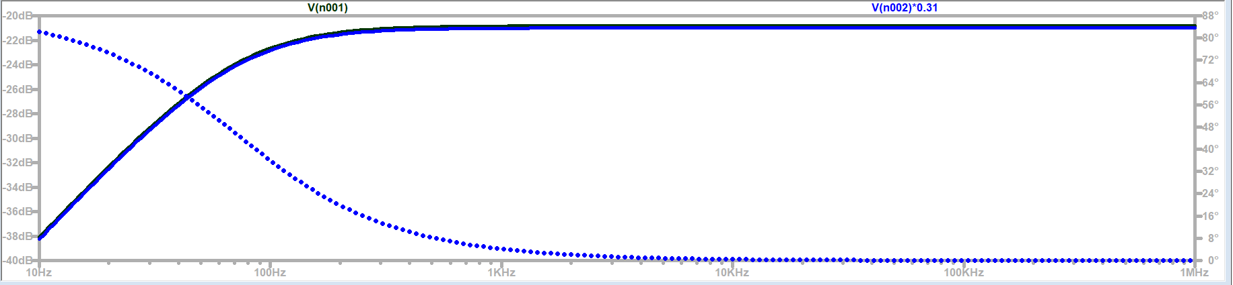

AC sweep plot of the turns ratio times the primary current, aIp, and the secondary current, Is. (LTspice)

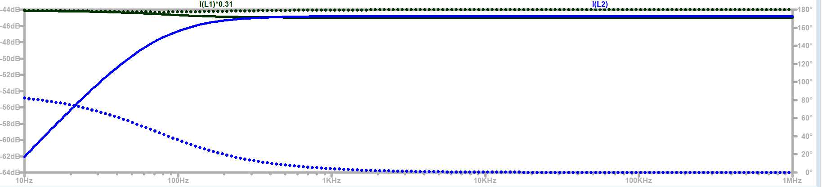
AC sweep plot of the input impedance divided by turns ratio squared, Rin/a². (LTspice)

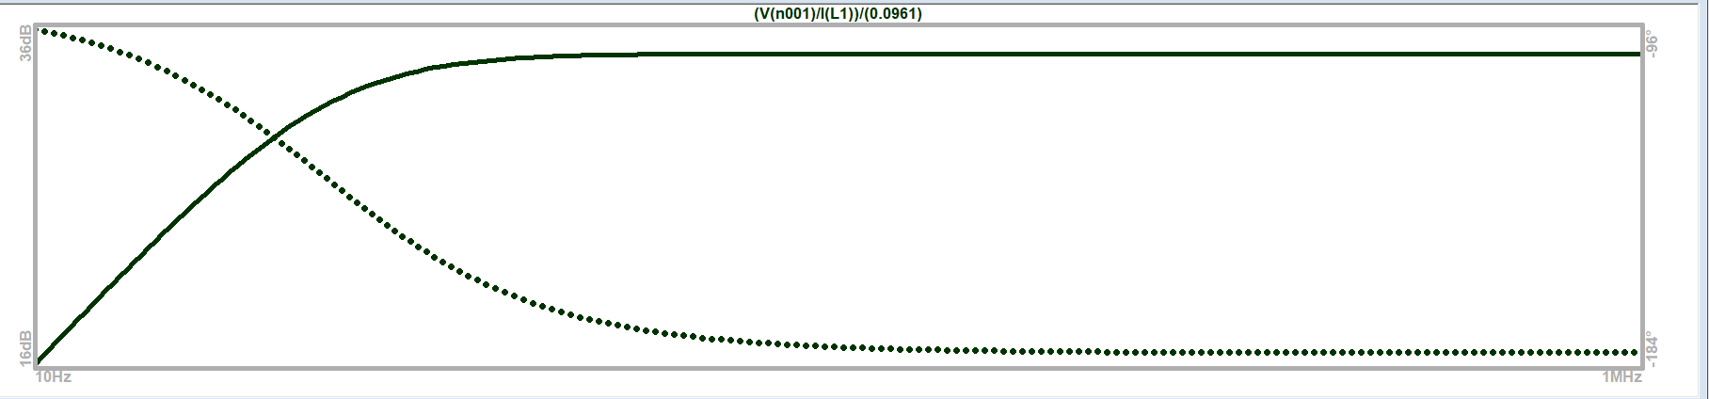

Verification of turns ratio plots by a TA/Instructor. ___________HC__________

Based on the above plots, over what range of frequencies are the transformer equations valid?

150hz to 1MegHz

What transformer property affects the range of frequencies where the transformer operates as expected?

The inductors are high pass filters therefore only high frequencies will allow the input signal to pass through.

Part B Operational Amplifiers
Brief description of the Operational amplifier experiment:
Create two basic op amp circuits (inverting and non-inverting) and check their outputs. Use resistors that create a gain of 3 to 4 in these circuits. Analyze and compare input and output voltages for both.

Sketch of the inverting amplifier circuit.

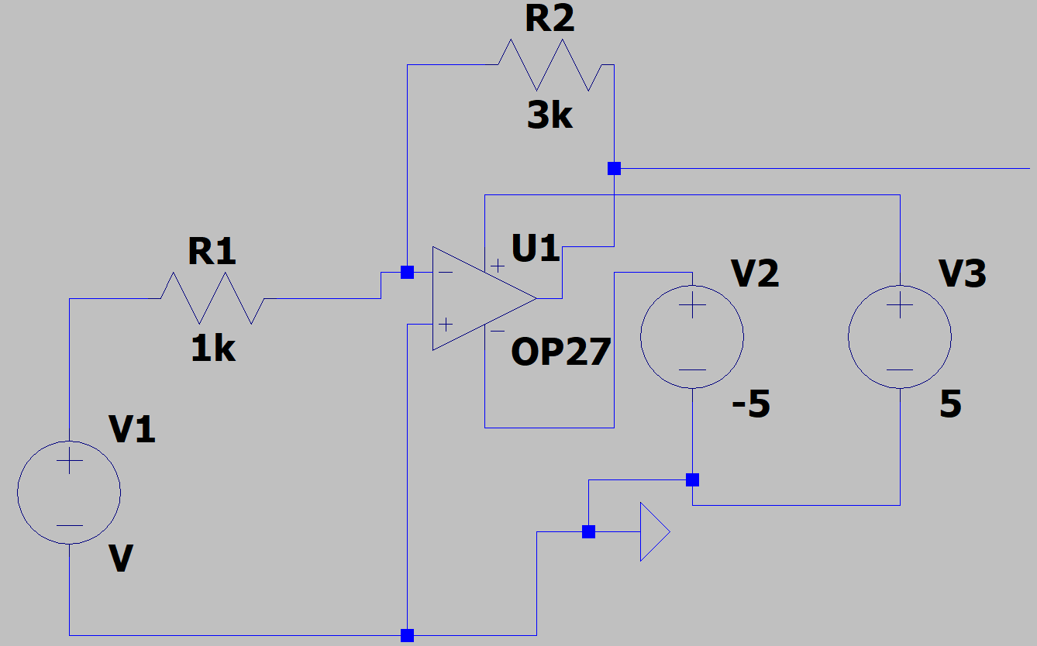

Resistor choices for the inverting amplifier to get a gain of -3 to -4.

R1 | 3000[Ω]
R2 | 1000[Ω]

Explanation of the circuit design/implementations to TA/Instructor. ____jb 3/8_____

Plot of the input voltage and output voltage as a function of time for the inverting amplifier circuit. (Discovery Board)

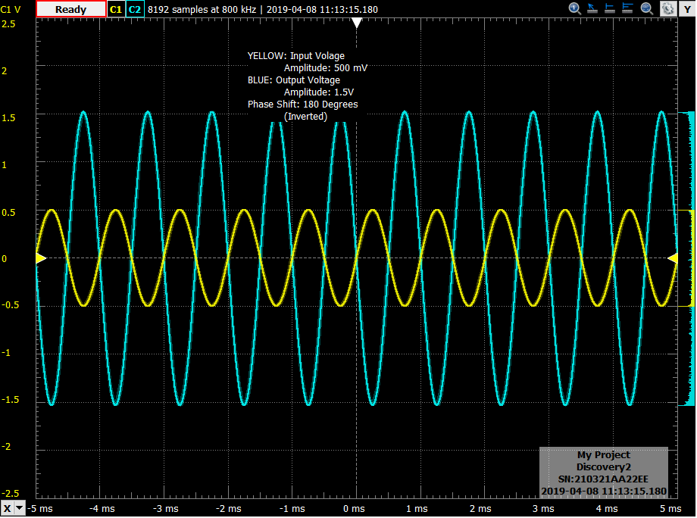
Sketch of the non-inverting amplifier circuit.

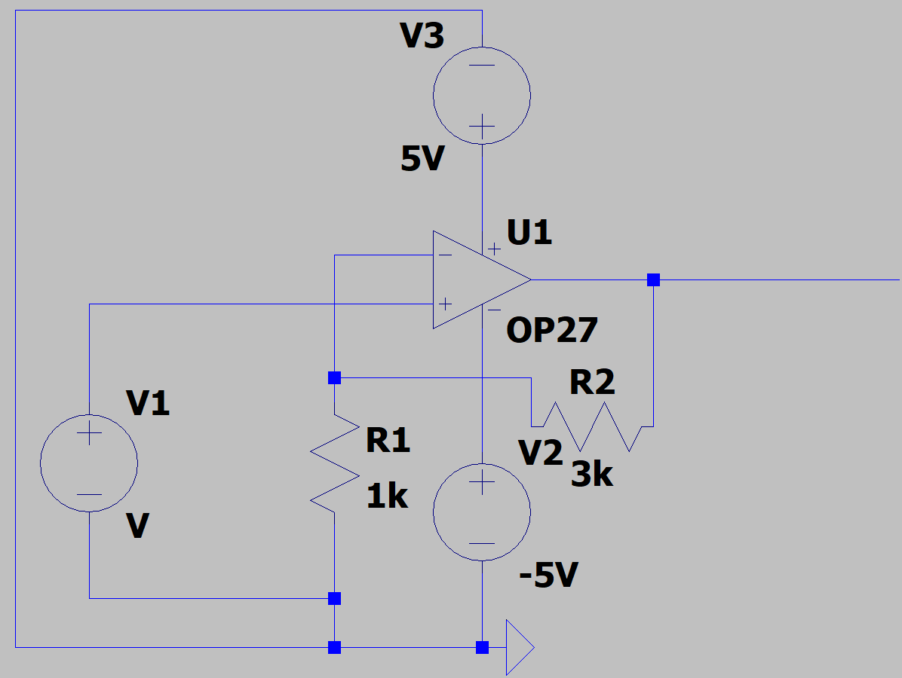

Resistor choices for the non-inverting amplifier to get a gain of 3 to 4.

R1 | 1000[Ω]
R2 | 3000[Ω]

Explanation of the circuit design/implementations to TA/Instructor. Jb 3/8

Plot of the input voltage and output voltage as a function of time for the non-inverting amplifier circuit. (Discovery Board)

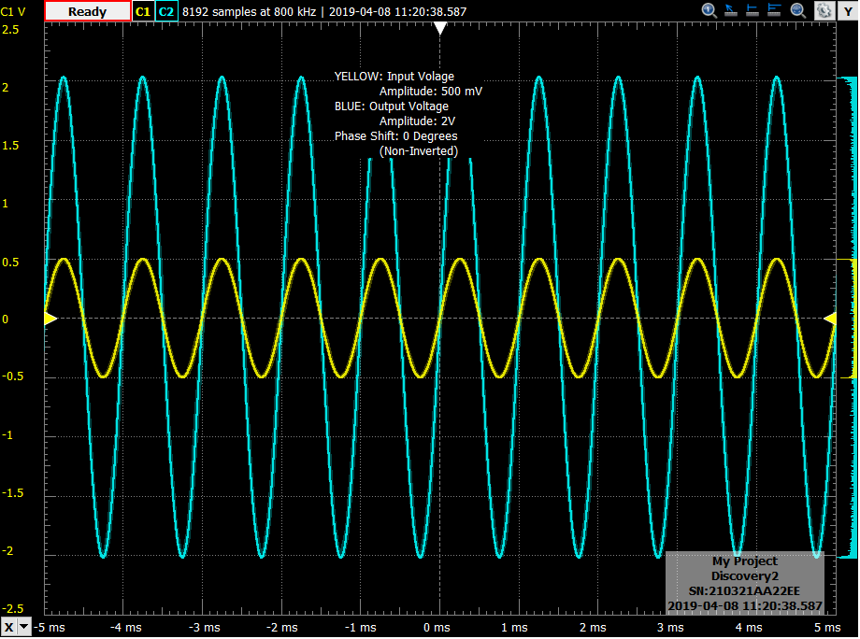
Part C
Brief description of Operational Amplifier model experiment:
Simulate a simple op amp circuit with a load, determine what configuration the op amp is in, and determine the ratio (gain). Simulate using LTspice.

Plot of the input voltage and output voltage as a function of time. (LTspice)

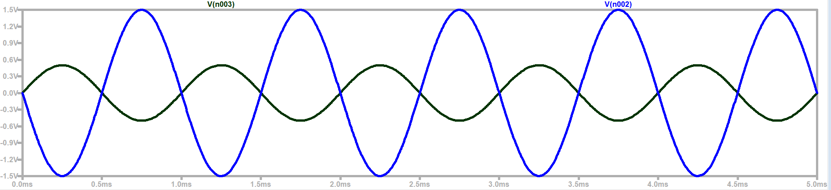
Blue= Output Voltage
Black- Input voltage

Operating as an Inverting Op amp circuit with a gain of around 3
Part E Reflection
What are the golden rules of op-amps and what evidence have you seen that shows they work?
The golden rule of op amps is that the output is entirely dependent on the position of the resistors, and the ratio of the resistors. This is shown between the differences in output and circuit diagram from the inverting and non-inverting op amp circuits. The circuits contain the same components but their positions are different resulting in outputs that have different phases and different gains associated with them.

Describe how a transformer works and what possibly limits its usefulness.
Two inductors overlap and one is connected to the input voltage function. Due to the changing current in the primary inductor it creates EMF that penetrates the second inductor as well. The number of turn ratio gives the voltage in the second inductor that can be used to power another circuit.
The limits of the transformer would be the inductors themselves. The more turns in the secondary inductor results in higher voltage but lower current, and may not be enough to drive the circuit. In addition, the operational frequency is something to consider as well as the inductors are high pass filters and operate at higher frequencies.

Do the same for operational amplifiers configured as inverting and non-inverting amplifiers
The operational amplifiers sense the voltage being inputted. Due to the feedback resistors the voltage drop is sensed by the op amp and the DC supplies try to make up for the loss. Based on the ratio of the resistors and the configuration of them in the circuit this creates a gain which in essence multiplies the input and results in a given output voltage.
The limitation of the op amp circuits are the DC supplies themselves. The op amp can only create output if the peak to peak range is within the range of the DC +/- supplies.

